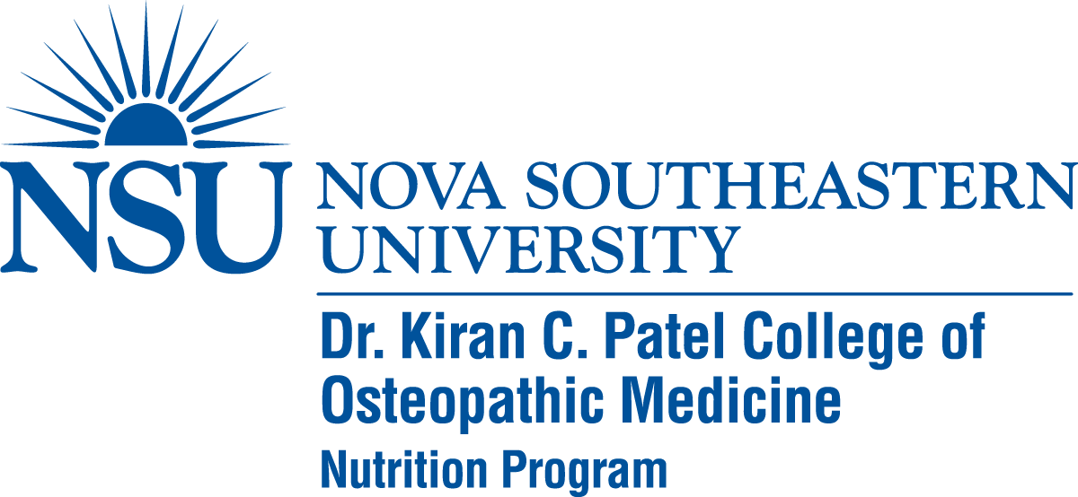
Scholarship Application - Graduate Nutrition Program
WINTER 2018

Through a generous benefactor grant, NSU’s Master of Science in Nutrition and Functional Nutrition and Herbal Therapy Certificate program is able to offer a limited number of $1,000 one-time scholarships to graduate students enrolled in the nutrition programs. As a strong supporter of our innovative programs, the donor’s goal for these scholarships is to raise awareness about whole food nutrition and use herbal supplements in wellness and medicine.
Scholarship eligibility:
- Health professions students or in current practice residency programs affiliated with NSU.
- Active enrollment in Graduate Certificate in Functional Nutrition and Herbal Therapy program or active enrollment in M.S. in Nutrition program with a declared concentration in Functional Nutrition and Herbal Therapy
- In good academic standing as defined by the Student Handbook
- Demonstrated interest and ability to apply the knowledge and skills from the program
- Completed scholarship application received by the December 20, 2017.

NAME ___________________________________ DATE OF APPLICATION: _________________

Describe your interest and current knowledge in functional nutrition and herbal therapy:

Describe how you envision using the course information:

What other financial assistance do you have for this certificate program?

Thank you very much for your consideration. If you have any questions please call Dr. Lynn Lafferty, program coordinator, at 954-262-1483. Return the completed form to nutrition@nova.edu .

