Dr. Kiran C. Patel College of Osteopathic Medicine
AIM-High Application, Summer 2018

Application Checklist:
- Application Form
- Required Essay Prompt – REQUIRED:
Please address both prompts below, in two pages or less (single‐spaced, typed, 1-inch margins).

1) Using only 3 adjectives, describe how others would characterize you.
2) In 300 words or less, let us know why you want to attend the AIM High program.
Articulate specific reasons why attending a medical immersion camp is important for you at this stage in your life and what you hope to learn (academically, personally and professionally)
through the experience.
  - Additional Scholarship Essay (if applicable)
- AIM-High Rules, Regulations, and Policies Form
- Participation Release of Liability and Assumption of Risk Agreement Form
- Nova Southeastern University Parent/Child Video/Photo Release Form
- AIM-High Health Form (physician signature required for all participants)
- Authorization for Medication/Treatment Form
- High School Transcript (non-official copies accepted)
- $25 non-refundable fee (please use Marketplace link on AIM-High website)
*Please note that applications will not be reviewed unless they are complete.

Please send completed application via e-mail to Oluseun Fajimolu at ofajimol@nova.edu
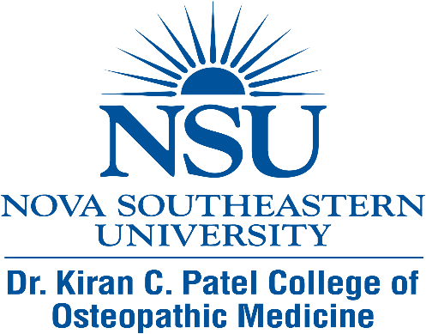

NOVA SOUTHEASTERN UNIVERSITY – DR. KIRAN C. PATEL
COLLEGE OF OSTEOPATHIC MEDICINE
AIM-HIGH SUMMER CAMP APPLICATION

SESSION I  JUNE 10-16, 2018 | SESSION II  JUNE 17-23, 2018

Applicant Information
Full Name: |  |  |  | D.O.B.:
 | Last | First | M.I.

Address:
 | Street Address | Apartment/Unit #

 | City | State | ZIP Code

Email: |  | Phone:

Cell:

High School Information

High School Name:

High School Address:

Street Address

 | City | State | ZIP Code

Parent/Guardian Information
Mother/Guardian: |  | Phone: |  | Email:

Father/Guardian: |  | Phone: |  | Email:

Preferred Session: | Session I (June 10-16, 2018) | Session II (June 17-23, 2018) | Either Session

Allergies/ Special Health Considerations:

Will you be flying in from out of the area? | Yes | No

Do you plan to park your personal vehicle at NSU?  Note: If you plan to park your vehicle at NSU, you MUST turn in your keys during check-in of your session. Your keys will be returned during check-out | Yes | No

Are you interested in applying for a needs-based scholarship? | Yes | No

Essay Prompt – REQUIRED:
- Using only 3 adjectives, describe how others would characterize you:

- In 300 words or less let us know why you want to attend the AIM-High program. Articulate specific reasons why attending a medical immersion camp is important for you at this stage in your life and what you hope to learn (academically, personally and professionally) through the experience.

The essay should be typed, single-spaced, and should not exceed two pages.

Needs-Based Scholarship Prompt (if Applicable):
We are committed to providing financial assistance to students who exhibit exceptional academic performance and outstanding promise.
Scholarships are need-based and applicants must submit a one-page essay describing why they are applying for a needs-based scholarship. Applicants should consider including information specific to familial circumstances that might make participation in AIM-High difficult without a scholarship. The essay must be typed, single-spaced and submitted along with the application.

T-Shirt Size:
Xtra Small Small Medium Large Xtra Large

