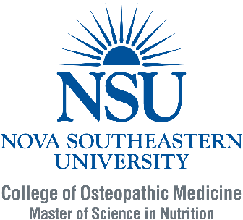
Scholarship Application - Graduate Nutrition Program
Through a generous benefactor grant, NSU’s Master of Science in Nutrition and Functional Nutrition and Herbal Therapy Certificate program is able to offer a limited number of $1,000 one-time scholarships to graduate students enrolled in the nutrition programs. As a strong supporter of our innovative programs, the donor’s goal for these scholarships is to raise awareness about whole food nutrition and use herbal supplements in wellness and medicine.
Scholarship eligibility:
- Health professions students or in current practice residency programs affiliated with NSU.
- Active enrollment in Graduate Certificate in Functional Nutrition and Herbal Therapy program or active enrollment in M.S. in Nutrition program with a declared concentration in Functional Nutrition and Herbal Therapy
- In good academic standing as defined by the Student Handbook
- Demonstrated interest and ability to apply the knowledge and skills from the program
- Completed scholarship application received by August 1, 2017

NAME ___________________________________ DATE OF APPLICATION: _________________

Describe your interest and current knowledge in functional nutrition and herbal therapy:

Describe how you envision using the course information:

What other financial assistance do you have for this certificate program?

Thank you very much for your consideration. If you have any questions please call Dr. Lynn Lafferty at 954-262-1483. Return to Dr. Lynn Lafferty at llaffert@nova.edu or fax to (954) 262-3806.

